Lab 11 to 20
Exp 11:
Aim:
To create a list containing different types of data and display it using R.
Procedure:
- Create a numeric vector.
- Create a matrix.
- Create a list containing the vector and matrix.
- Display the list.

Code:
numbers <- c(10, 20, 30, 40)

marks <- matrix(c(80, 85, 90, 95), nrow = 2)

my_list <- list(
Numbers = numbers,
Marks = marks,
Name = "Student"
)

print(my_list)

Result:
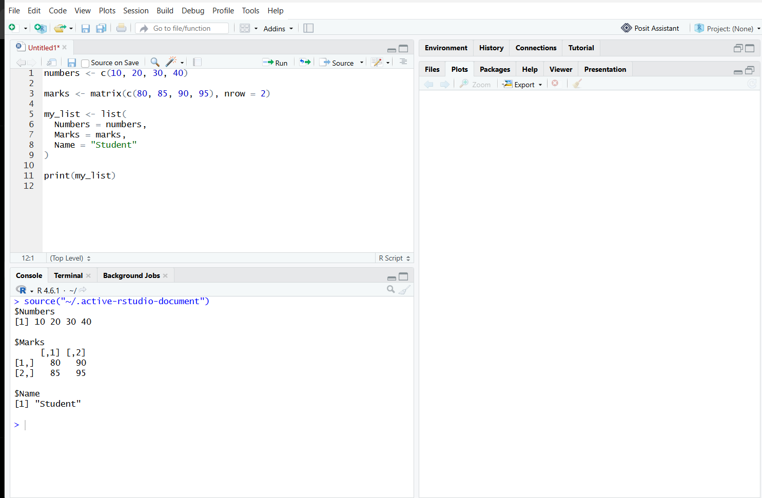

- A list containing a numeric vector, a matrix, and a character value is created and displayed successfully.

Exp 12:

Aim:
To create a factor from categorical data and display its levels.
Procedure:
- Create a character vector containing categories.
- Convert the vector into a factor using factor().
- Display the factor.
- Display the available levels.
Code:
gender <- c("Male", "Female", "Male", "Female")

gender_factor <- factor(gender)

print(gender_factor)
print(levels(gender_factor))

Result:

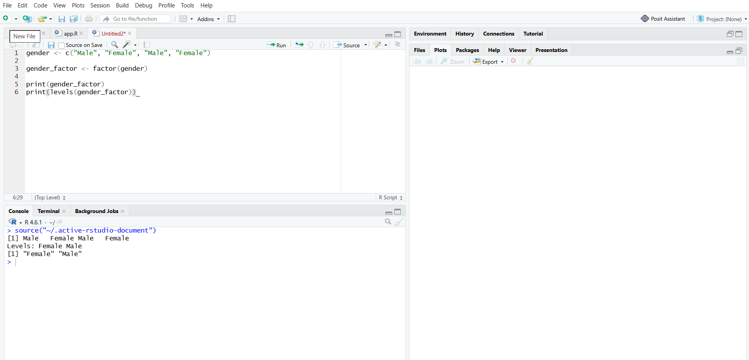
Exp 13:

Aim:
To create and display a three-dimensional array using R.
Procedure:
- Create a sequence of numbers from 1 to 24.
- Use the array() function.
- Specify three dimensions.
- Display the array.
Code:
a <- array(1:24, dim = c(3, 4, 2))

print(a)
Result:
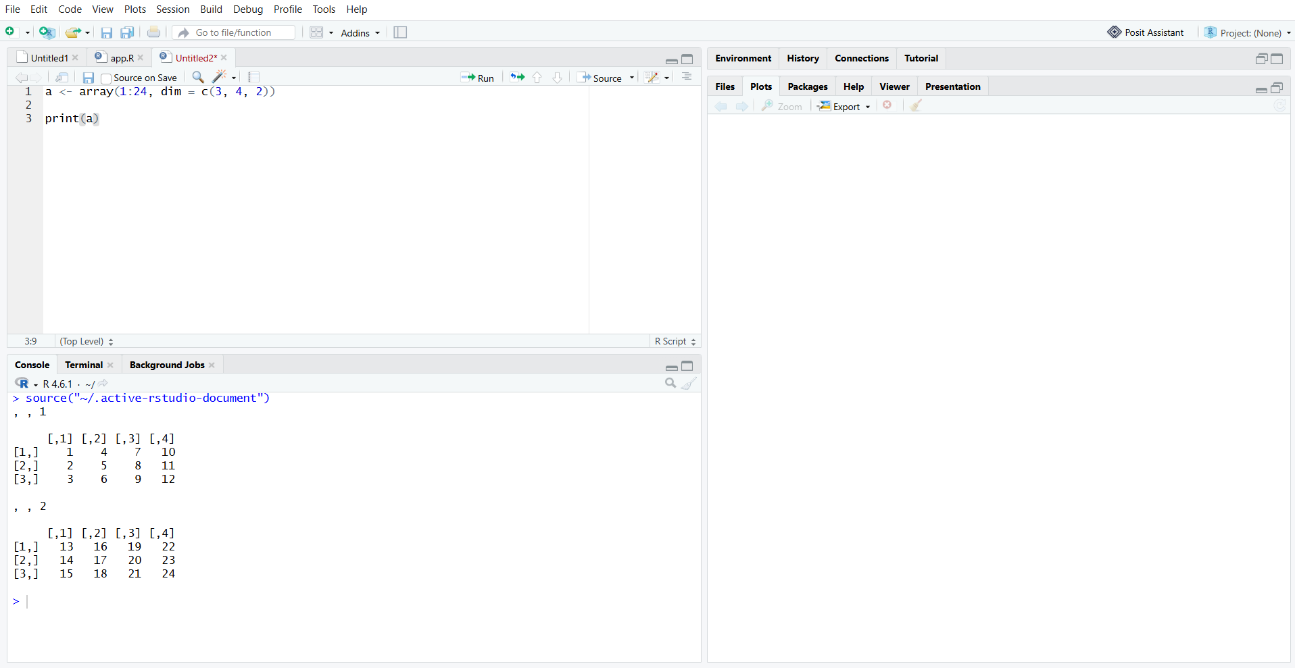
Exp 14:
Aim:
To generate random values from a normal distribution and display them using a histogram.

Procedure:
- Set a random seed.
- Generate 100 random values using rnorm().
- Display the first six values.
- Use hist() to plot the values.

Code:
set.seed(123)

x <- rnorm(100)

print(head(x))

hist(x,
main = "Normal Distribution",
xlab = "Values",
ylab = "Frequency",
col = "lightblue")

Result:

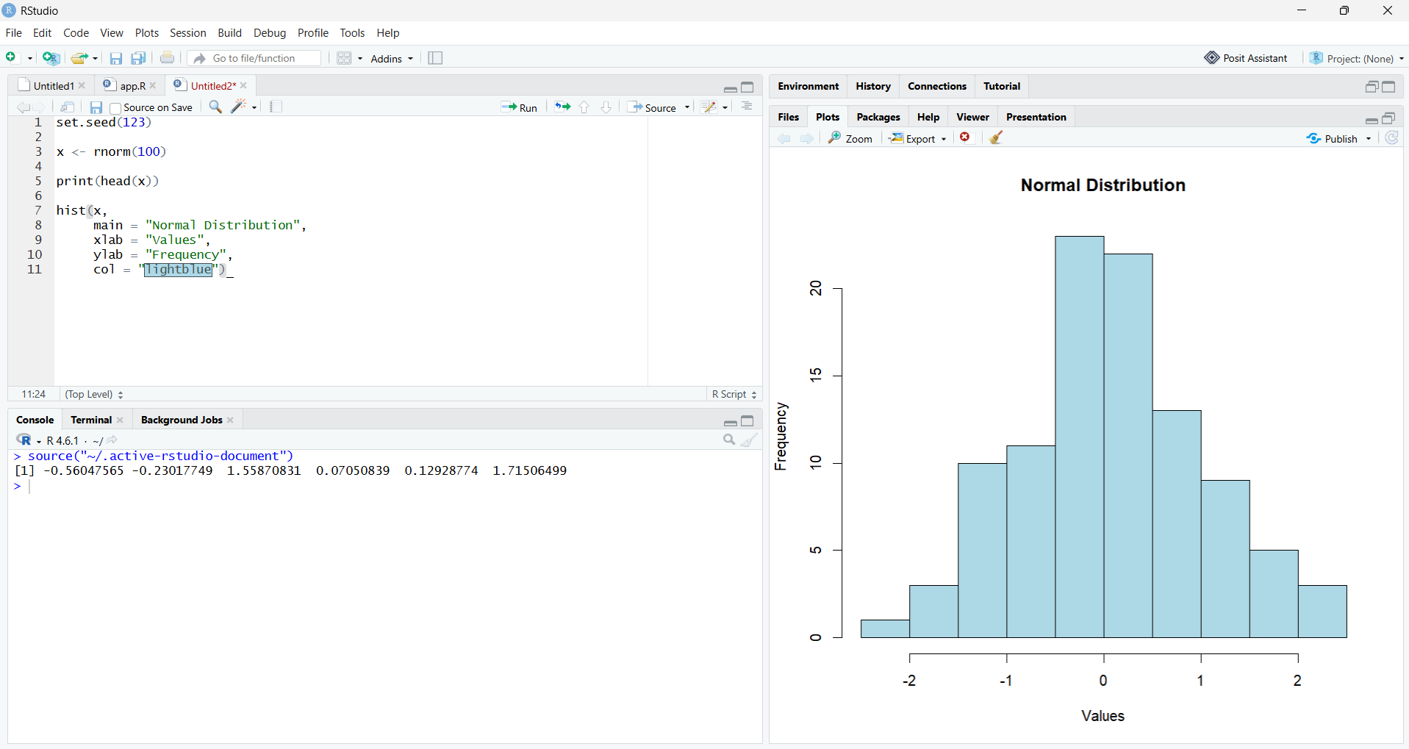

Exp 15:
Aim:
To create a data frame, sort student marks, and display the marks using a bar graph.
Procedure:
- Create student names and marks.
- Combine them into a data frame.
- Add a grade column.
- Sort the data by marks.
- Use barplot() to display student marks.
Code:
student <- c("Arun", "Priya", "Rahul", "Divya")
marks <- c(85, 92, 75, 88)

data <- data.frame(student, marks)
data$grade <- c("B", "A", "C", "B")

print(data)

sorted_data <- data[order(data$marks), ]
print(sorted_data)

barplot(data$marks,
names.arg = data$student,
main = "Student Marks",
xlab = "Students",
ylab = "Marks",
col = "lightgreen")

Result:
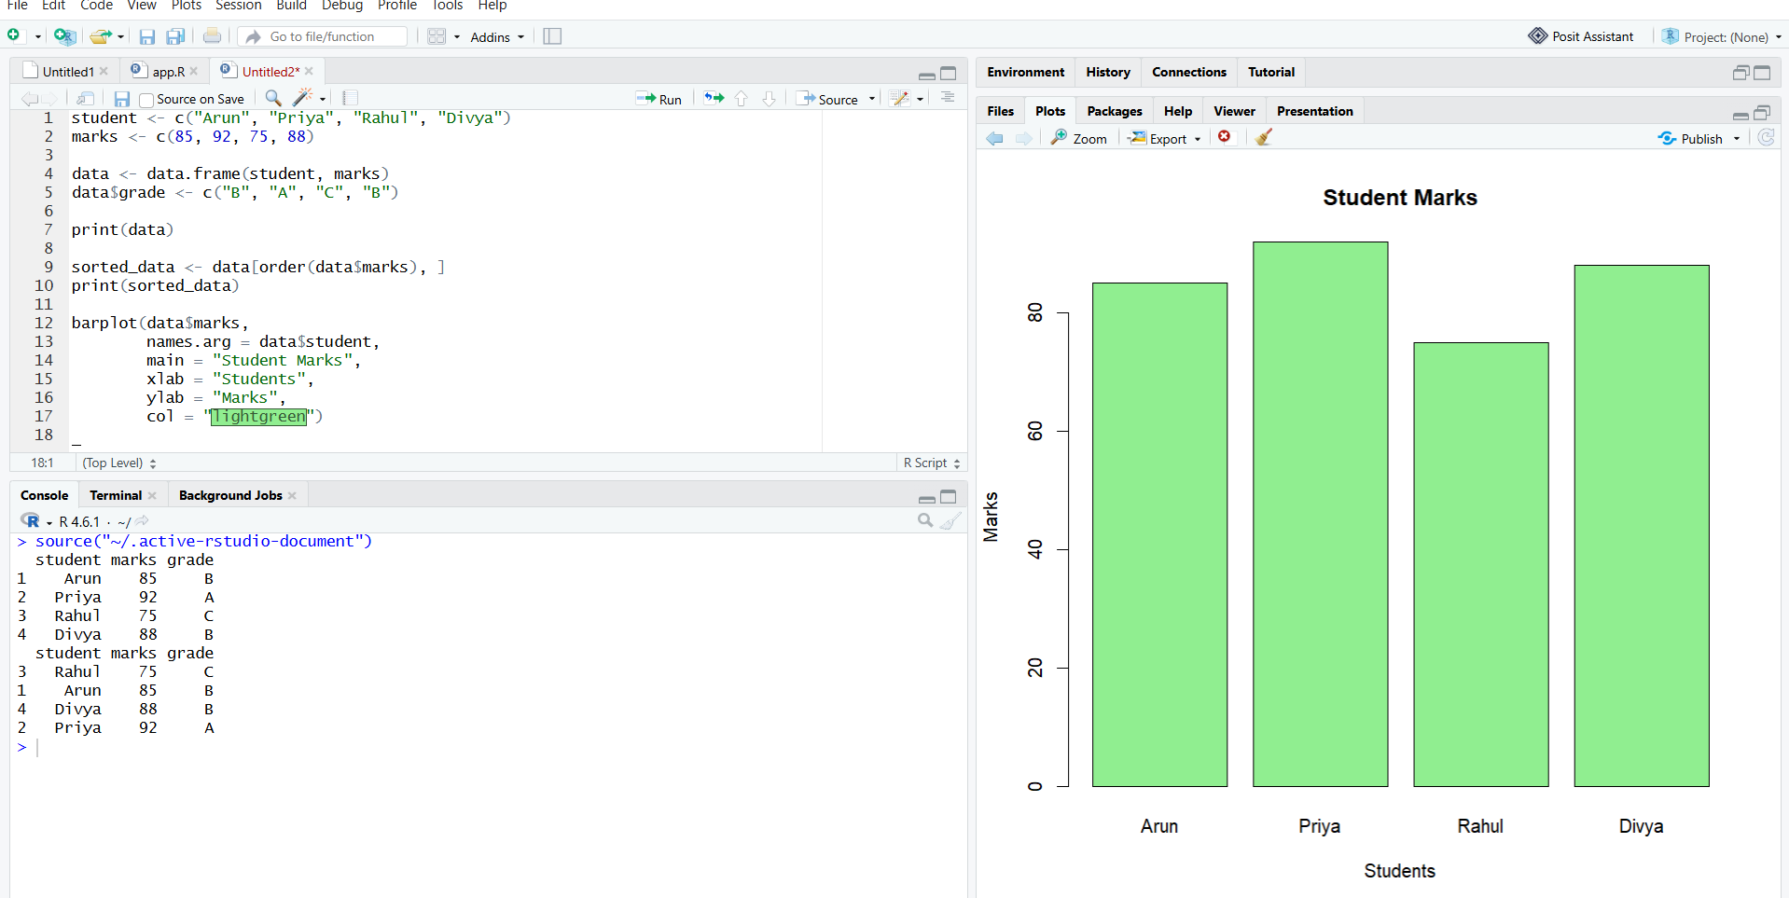

Exp 16:
Aim:
To create, save, read, and display data from a CSV file using R.
Procedure:
- Create a student data frame.
- Save the data as a CSV file.
- Read the file using read.csv().
- Display the data.
- Plot the student marks using a bar graph.
Code:
student <- data.frame(
Name = c("Arun", "Priya", "Rahul"),
Marks = c(85, 92, 78)
)

write.csv(student, "students.csv", row.names = FALSE)

data <- read.csv("students.csv")

print(data)

barplot(data$Marks,
names.arg = data$Name,
main = "Student Marks from CSV",
xlab = "Students",
ylab = "Marks",
col = "orange")

Result:
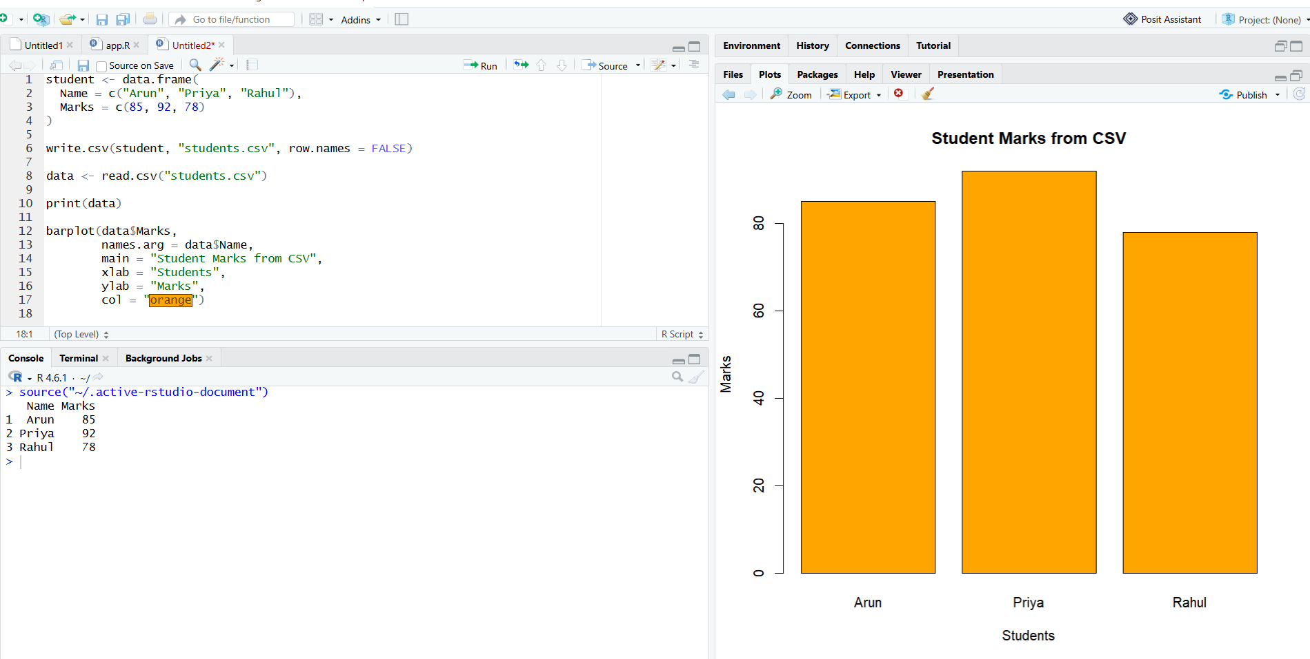

Exp:17
Aim:
To calculate monthly average ozone values from the built-in airquality dataset and display them using a graph.
Procedure:
- Load the airquality dataset.
- Remove records with missing values in the required columns.
- Calculate average ozone values by month.
- Display the calculated averages.
- Plot the averages using a bar graph.

Code:
data(airquality)

clean_data <- na.omit(airquality[, c("Ozone", "Month")])

monthly_avg <- aggregate(
Ozone ~ Month,
data = clean_data,
FUN = mean
)

print(monthly_avg)

barplot(monthly_avg$Ozone,
names.arg = monthly_avg$Month,
main = "Monthly Average Ozone",
xlab = "Month",
ylab = "Average Ozone",
col = "lightblue")

Result:
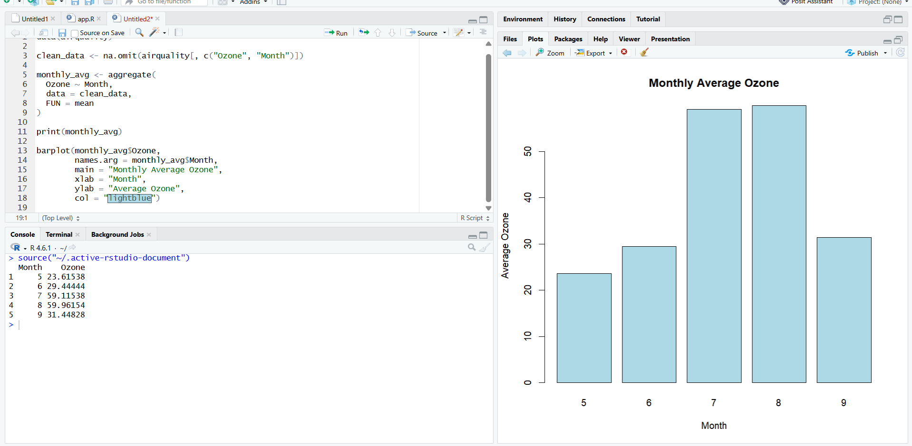

Exp 18:
Aim:
To analyze the Iris dataset and compare sepal lengths across different species using a boxplot.
Procedure
- Load the built-in iris dataset.
- Display the first six records.
- Display summary statistics.
- Calculate average sepal length for each species.
- Plot sepal lengths using a boxplot.
Code:
data(iris)

print(head(iris))
print(summary(iris))

avg_length <- aggregate(
Sepal.Length ~ Species,
data = iris,
FUN = mean
)

print(avg_length)

boxplot(Sepal.Length ~ Species,
data = iris,
main = "Sepal Length by Species",
xlab = "Species",
ylab = "Sepal Length",
col = "lightgreen")

Result:
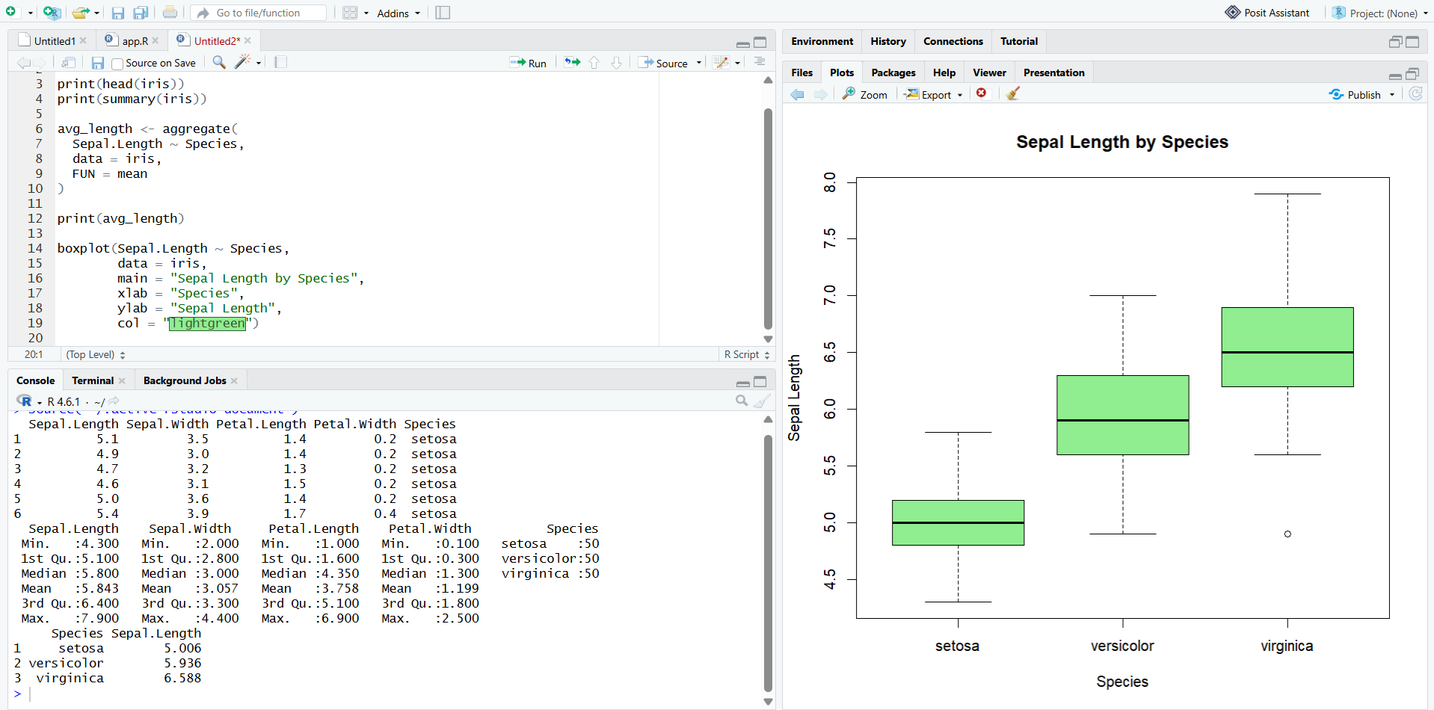

Exp 19:
Aim:
To perform simple linear regression and display the relationship between advertising spending and sales using a scatter plot.
Procedure:
- Create sample spending and sales data.
- Fit a linear regression model using lm().
- Display the model summary.
- Predict sales for a new spending value.
- Plot the data and regression line.
Code:
Spend <- c(10, 20, 30, 40, 50)
Sales <- c(15, 25, 35, 45, 55)

data <- data.frame(Spend, Sales)

model <- lm(Sales ~ Spend, data = data)

print(summary(model))

new_data <- data.frame(Spend = 60)
print(predict(model, newdata = new_data))

plot(Spend, Sales,
main = "Spend vs Sales",
xlab = "Advertising Spend",
ylab = "Sales",
pch = 19)

abline(model, col = "red", lwd = 2)
Result:
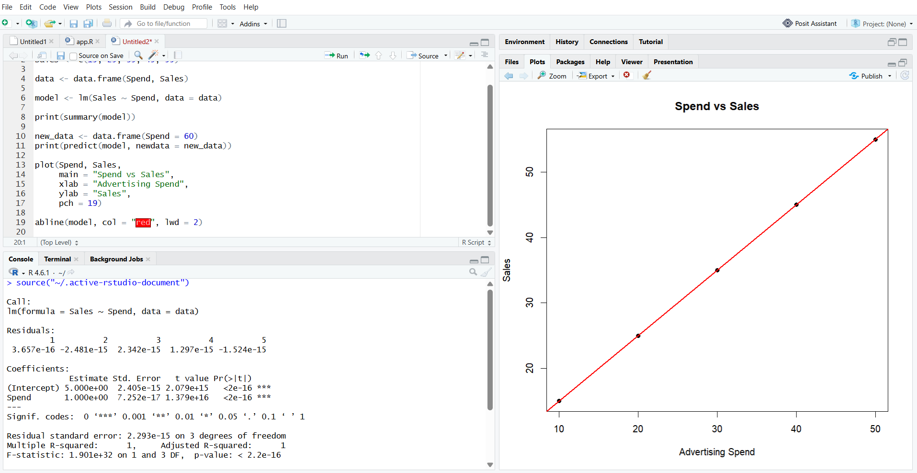

Exp 20:
Aim:
To perform logistic regression on the Iris dataset and display the predicted probabilities using a graph.
Procedure:
- Load the Iris dataset.
- Create a binary target variable for the setosa species.
- Fit a logistic regression model using glm().
- Calculate predicted probabilities.
- Display the probabilities using a scatter plot.
Code:
data(iris)

iris$IsSetosa <- ifelse(
iris$Species == "setosa", 1, 0
)

model <- glm(
IsSetosa ~ Sepal.Length + Sepal.Width,
data = iris,
family = binomial
)
probability <- predict(model, type = "response")

print(head(probability))

plot(iris$Sepal.Length, probability,
main = "Logistic Regression",
xlab = "Sepal Length",
ylab = "Predicted Probability",
pch = 19,
col = "blue")
Result:

